Overview:

=========

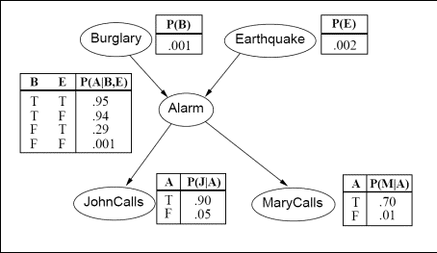

For the Bayesian network of Figure 1, implement a program that computes and prints out the probability of any combination of events given any other combination of events. If the executable is called bnet, here are some example invocations of the program:

1. To print out the probability P(Burglary=true and Alarm=false | MaryCalls=false).
2. bnet Bt Af given Mf
3. To print out the probability P(Alarm=false and Earthquake=true).
4. bnet Af Et
5. To print out the probability P(JohnCalls=true and Alarm=false | Burglary=true and Earthquake=false).
6. bnet Jt Af given Bt Ef
7. To print out the probability P(Burglary=true and Alarm=false and MaryCalls=false and JohnCalls=true and Earthquake=true).
8. bnet Bt Af Mf Jt Et

In general, bnet takes 1 to 6(no more, no fewer) command line arguments, as follows:

* First, there are one to five arguments, each argument specifying a variable among Burglary, Earthquake, Alarm, JohnCalls, and MaryCalls and a value equal to true or false. Each of these arguments is a string with two letters. The first letter is B (for Burglary), E (for Earthquake), A (for Alarm), J (for JohnCalls) or M (for MaryCalls). The second letter is t (for true) or f (for false). These arguments specify a combination C1 of events whose probability we want to compute. For example, in the first example above, C1 = (Burglary=true and Alarm=false), and in the second example above C1 = (Alarm=false and Earthquake=true).
* Then, optionally, the word "given" follows, followed by one to four arguments. Each of these one to four arguments is again a string with two letters, where, as before the first letter is B (for Burglary), E (for Earthquake), A (for Alarm), J (for JohnCalls) or M (for MaryCalls). The second letter is t (for true) or f (for false). These last arguments specify a combination of events C2 such that we need to compute the probability of C1 given C2. For example, in the first example above C2 = (MaryCalls=false), and in the second example there is no C2, so we simply compute the probability of C1, i.e., P(Alarm=false and Earthquake=true).

The implementation should not contain hardcoded values for all combinations of arguments. Instead, your code should use the tables shown on Figure 1 and the appropriate formulas to evaluate the probability of the specified event. It is OK to hardcode values from the tables on Figure 1 in your code, but it is not OK to hard code values for all possible command arguments, or probability values for all possible atomic events. More specifically, for full credit, the code should include and use a Bayesian network class. The class should include a member function called computeProbability(b, e, a, j, m), where each argument is a boolean, specifying if the corresponding event (burglary, earthquake, alarm, john-calls, mary-calls) is true or false. This function should return the joint probability of the five events.

Programming Language

===================

Java

Instructions to compile & run the code

==============================

Compile: Execute following command to compile the code.

javac \*.java

Run: Execute following command to run the program.

SYNTAX : java bnet <input events>

For e.g. : java bnet Bt Af given Mf